

**Dr. D.Y. Patil**

**Institute Of Management**

**& Entrepreneur Development**

**Department of MCA**

A Project Report On

**Newspaper Billing System**

Submitted to

Savitribai Phule Pune University, Pune

F.Y.MCA.

(Academic Year :2022-2023)

By

* **Kaustubh Shinde (21109)**
* **Atifa Kadri (21008)**
* **Shweta Bhandare (21014)**
* **Shubham Halijwale (21040)**

Under the Guidance of

**Prof. Harini Pawar**



**Dr. D.Y. Patil**

**Institute Of Management**

**& Entrepreneur Development**

**Department of MCA**

**CERTIFICATE**

This is to certify that the project entitled “**Newspaper Billing System** ” submitted by **Kaustubh Shinde , Atifa Kadri , Shweta Bhandare , Shubham Halijawale** in partial fulfillment of the requirement of the award of degree MCA to Savitribai Phule Pune University, Pune has been carried out by them under my guidance satisfactorily during the academic year 2022-2023.

Date :

**Project Guide.** Internal External HOD

Examiner Examiner MCA

**ACKNOWLWDGEMENT**

**I** would like to express my special thanks of gratitude to my Project Teacher “**Prof. Harini Pawar.**” for her valuable guidance and support in completing my Project.

**I** would also like to extend my gratitude to the Director Sir “**Tanaji Dabade**” to providing me with all the facilities that was required.

**DATE :**

**INDEX**

|  |  |  |
| --- | --- | --- |
| **Sr.No.** | **Contents** | **Page No.** |
| 1 | Problem Definition |  |
| 2 | Scope of System |  |
| 3 | Need of System |  |
| 4 | Proposed System |  |
| 5 | System Requirements |  |
| 6 | Fact Finding Techniques |  |
| 7 | Feasibility Study |  |
| 8 | E-R Diagram |  |
| 9 | Class Diagram |  |
| 10 | Use Case Diagram |  |
| 11 | Sequence Diagram |  |
| 12 | Activity Diagram |  |
| 13 | Data Dictionary |  |
| 14 | Input Output Screens |  |
| 15 | Testing |  |
| 16 | Future Enhancements |  |
| 17 | Conclusion |  |
| 18 | Bibliography |  |

**PROBLEM**  **DEFINITION**

We have designed this " **Newspaper Billing System** " to maintain the transaction such as generating bill of shop. We have developed this software by analyzing the requirements of the shop & the problems of the existing system. Proposed software is helpful for that shop.

This system is designed using “JAVA” as front-end & “MYSQL” as back-end tool.

**SCOPE OF SYSTEM**

Scope of system will define the boundaries of the system.

**I. Master Maintenance**:

Maintaining the detailed information regarding the customer, bill data.

**II. Bill**:

Generates bill as per order taken from the customer.

**NEED OF SYSTEM**

* In this system, we store record of customer.
* To maintain the Newspaper information.
* To reduce paperwork.
* To generate bill of Newspaper to give the customer.
* To generate bill from shop owner to customer.

**PROPOSED SYSTEM**

* In this system we will keep information about all the customers and their transaction with their bills.
* It helps to billing very easily.
* Various report is generated by the system are designed according to the Shop need. This would be effective measures for better Customer satisfaction.

**SYSTEM REQUIREMENT**

Technologies and tools used in Policy system project are as follows

Technology used:

**Front-End**

* JAVA

**Back-End**

* MYSQL

**Environment requirement:**

The environment requirement consists of requirements as follows for this system: -

***Hardware Requirements: -***

1)Computer

2)Hard Drive :1TB

3)RAM :4GB

4)Processor: Pentium4 or above

5)Printer: Any Type of Printer

***Operating System: -***

Windows10

**FACT FINDING** **TECHNIQUES**

To study the system, we need to find the facts. Facts expressed in quantitative form can be termed as data. Success of any requirement investigation availability of accurate and reliable data. The specific methods used for collecting data are called fact finding technique.

We have used four fact finding techniques in the process of system analysis.

* Record review.
* Observation.

Record review:

Many kind of records and reports can provide valuable information about organization and operation. In record reviews, we examine information that has been recorded about the users. This was the most beneficial technique for a while making our database. We perform this technique at the beginning of the study as introduction.

Observation:

We paid at attention to the transaction, usage of file and documents, the record keeping and the handling of queries in the existing system. Observation helped us in the finding out actual way of functioning apart from the ideal or desire.

**FEASIBILITY STUDY**

Before recommending a new system, it is investigated that whether it is possible to develop the requested system. The important outcome of the preliminary investigation is the determination that the system requested is feasible for the user/organization or not. There are three aspects of feasibility study. These three aspects can be listed as follow:

* **Technical Feasibility**

In this type of feasibility study, System developer must check whether it is possible to develop the requested system with the available requirements. Besides we must check the availability of the other resources like the manpower, software, hardware, etc.

We have used all already existing end easily available technical resources for the development of ‘**Newspaper Billing System’** such as java programming language (Open Source), Third Party(API) which serves as a base for Newspaper Billing System. So, what we intended to do was technically feasible.

* **Economic Feasibility**

To prepare a system most important aspect is whether we can afford it or not? In this type of feasibility study, cost benefit analysis is done. It is checked to see if there are sufficient benefits from the system to make the cost involved acceptable.

We have used all the open source resources such as java programming language and freely available Third party API's so cost incurred is negligible.

* **Operational Feasibility**

In this type of feasibility study, we consider operational implementation of the system. It is checked that whether it is feasible to the user to operate the software or will the user resist? Thus, the computerized proposed system is said to be operationally feasible if the users of the system can understand the system correctly, that is the user should have the capacity of analyzing the system. The system should also take care of the user acceptance and satisfy business rules.

This software will be of immense use to the people who have low vision, reading disabilities or take delight in relaxing and listening to an audio than reading long documents. As the application provides a user-friendly GUI, it’s possible for any person to handle our application without in-depth knowledge of computers

have

User

purchase

generate

Bill

pays

Customer

**ER-Diagram**

has

Newspaper Agency

1 M

1 1 1

1

1 1

1

M M 1

**Class Diagram**

generate

1 pay 1 1

has 1

**Customer**

c_id : int

c_name : varchar

c_phone : long

insert()

search()

update()

delete()

Bill For Customer

Cb_id : int

date : date

amount : int

c_id : int

p_id : int

insert()

generatePdf()

delete()

Newspaper Agency

name : varchar

1 1 1 1

1

have 1

purchase

1..* 1

Login

-UserName:String

-Password:String

+VerifyLogin():Boolean

**Use Case Diagram**

**Newspaper Agency Customer**

**Sequence Diagram**

Newspaper Agency

Customer

Purchase Newspaper

Pay Bill

**Activity Diagram**

Give amount from Customer

Print Bill

Customer Details

Add NewsPaper

Login

Yes No

<< try again >>

**Data Dictionary**

**1)Login Table :**

|  |  |  |  |
| --- | --- | --- | --- |
| **Field Name** | **Data Type** | **Constraints** | **Description** |
| login_name | Varchar(20) | Not Null | This is a username. |
| Password | varchar(20) | Not Null | This is a Password. |
| Ques | varchar(20) | Not Null | This is Question to recover password |
| Ans | varchar(20) | Not Null | This is Answer of Question of recovery. |

**4)Customer Table:**

|  |  |  |  |
| --- | --- | --- | --- |
| **Field Name** | **Data Type** | **Constraints** | **Description** |
| c_id | numeric(6) | Not Null (PK) | This is a Customer no. |
| c_name | varchar(20) | Not Null | This is Customer name. |
| c_add | varchar(30) | Not Null | This is Customer Address. |
| c_phone | long(10) | Not Null | This is Customer Phone no. |
| c_mail | varchar(20) | Not Null | This is Customer mail id. |

**5)Customer Bill Table:**

|  |  |  |  |
| --- | --- | --- | --- |
| **Field Name** | **Data Type** | **Constraints** | **Description** |
| Cbill | numeric(6) | Not Null (PK) | This is a Bill no. |
| Dt | Date | Not Null | This is Bill generation Date. |
| c_id | numeric(6) | Not Null(FK1) | This is Foreign Key From Customer. |
| C_name | Numeric(6) | Not Null | This is Customer name |
| qunt | numeric(6) | Not Null | This is Quantity. |
| Amt | numeric(6) | Not Null | This is Total Amount with GST. |

**6)Report Login Table :**

|  |  |  |  |
| --- | --- | --- | --- |
| **Field Name** | **Data Type** | **Constraints** | **Description** |
| Name | varchar(20) | Not Null | This is a username. |
| Password | varchar(20) | Not Null | This is a Password. |
| Ques | varchar(20) | Not Null | This is Question to recover password |
| Ans | varchar(20) | Not Null | This is Answer of Question of recovery. |

**INPUT OUTPUT SCREENS**

* **Login Frame**

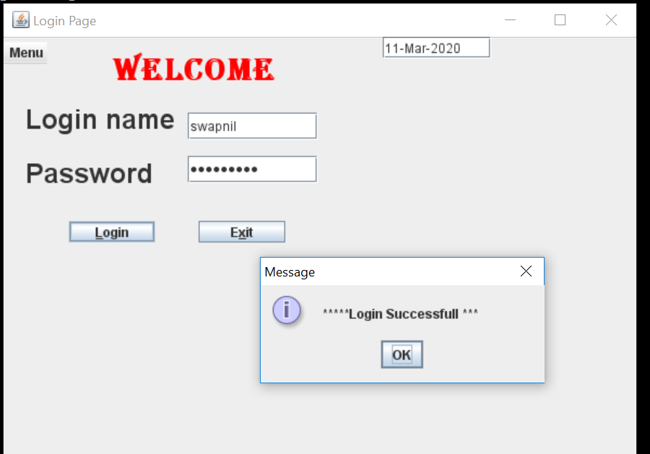

* **Recovery Frame**

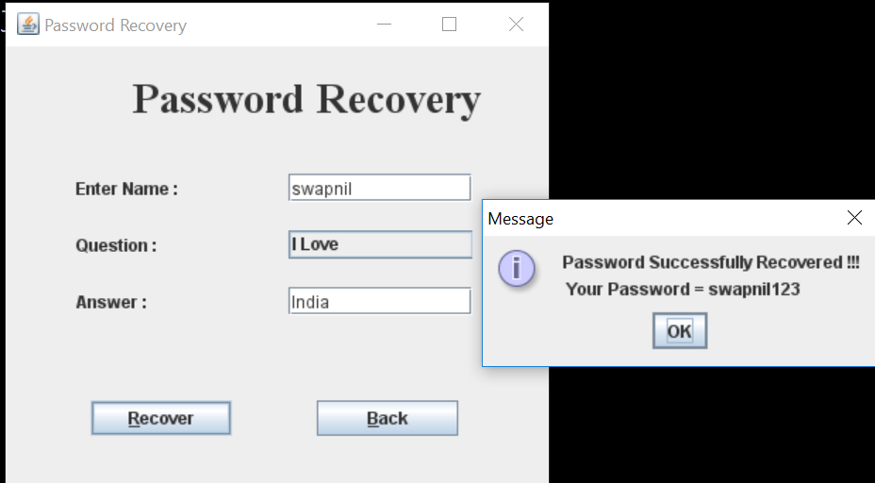

* **Main Frame**

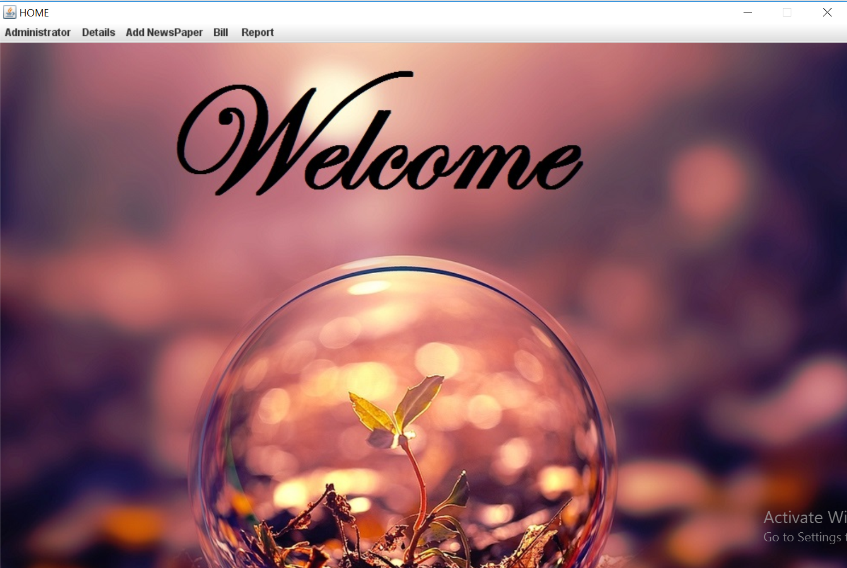

* **Customer Saved Frame**

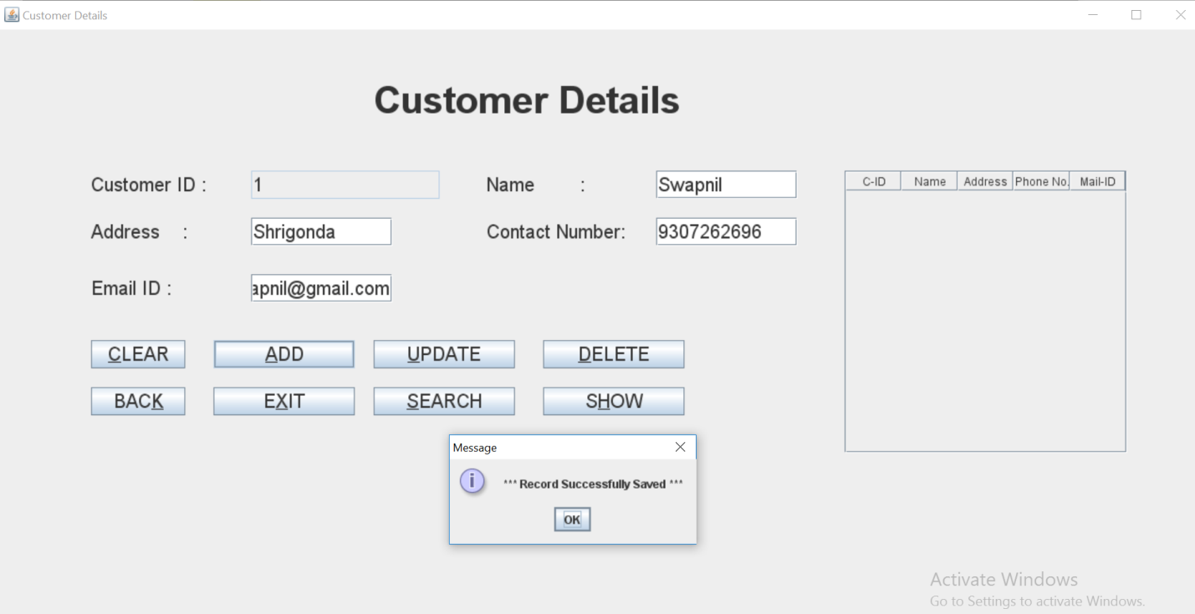

* **Newspaper Entry Frame**

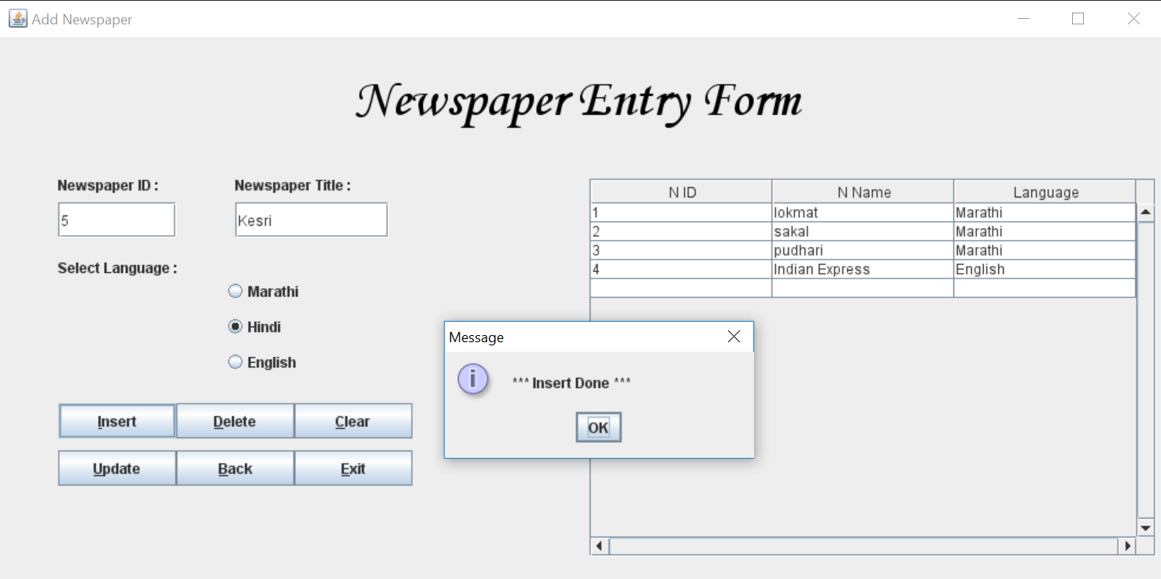

* **Customer Bill Frame**

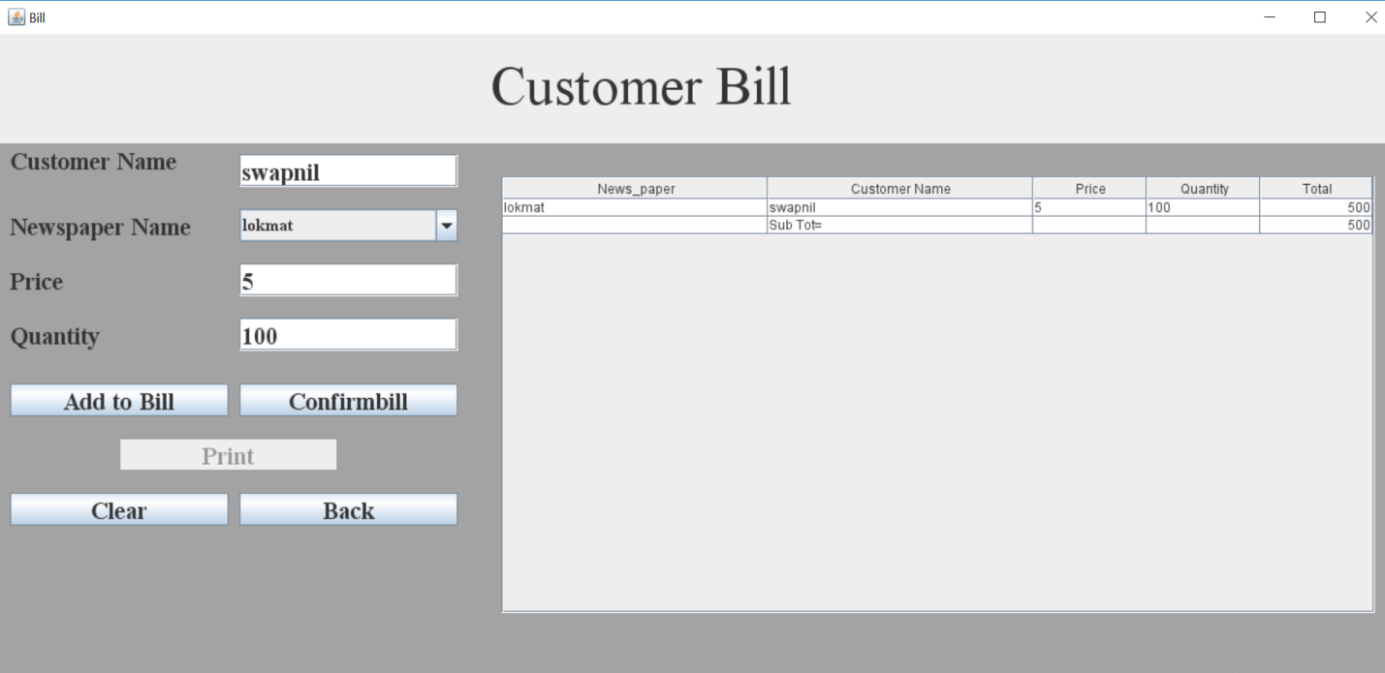

* **Customer Bill Print**

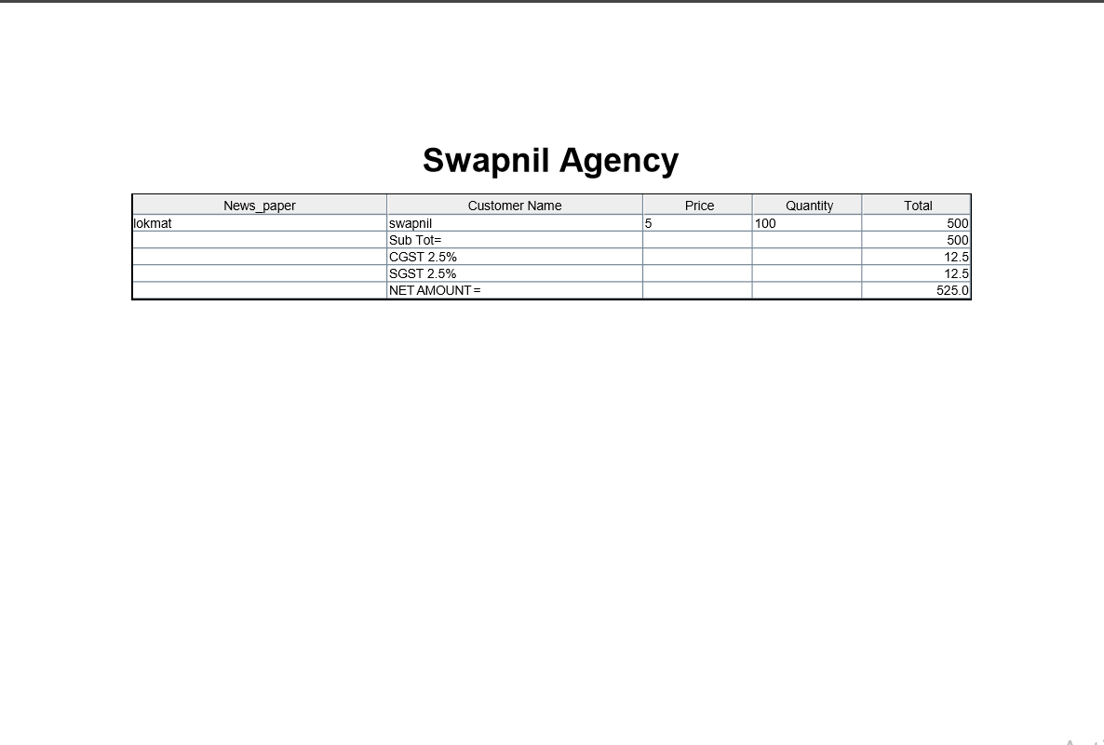

* **Bill Report Frame**

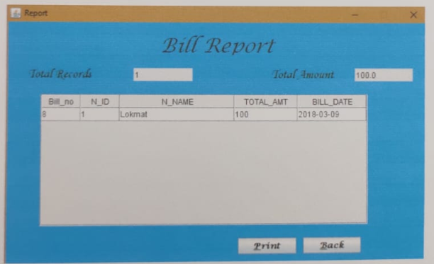

**TESTING**

As the **Newspaper Billing System**, there are various types of test methods we need to apply for the application test. In general practices, there are Three types of test methodologies that need to be used for database testing.

Types Of Testing: -

1.Unit Testing:

A unit testing is the smallest testable part of any software.

2.Module Integration Testing:

A module integration testing is the phase in software testing in which individual software modules are combined and tested as a group.

3.System Testing:

A system testing is the testing of a complete and fully integrated software product.

**FUTURE ENHANCEMENT**

This system is improved in future by adding following things -

* More security provides for reports and transaction.
* This system will be modified for multi-user system.
* More security for member data.
* More service provided to customer.

**CONCLUSION**

In this system, we have studied different management systems used during evaluation and presented a low-cost shop management system software with the help of that study. We have learned a lot about document writing during this progression. The process of writing this is document, which is a research paper, was not familiar to me, but of great benefit.

The application **Newspaper Billing System** System is created to help small businesses to transfer their records from paper based system to computerized system, even with a low budget.

At the same time, the requirements of a basic shop have been taken care of and a few features that can make the system easier to use and easy to understand to the user with beginner level knowledge of computers have been added.

I hope that **Newspaper Billing System** fulfills all basic requirements for shop with intention of transferring to computerized billing system.

**BIBLIOGRAPHY**

* **Books -**

1) Programming in Java I

-Poonam Ponde

2) Java Black Book

-Steve Holzner

3) Programming in Java II

-Poonam Ponde

* **Websites -**

[**www.Google.com**](http://www.google.com/)

[**www.W3school.com**](http://www.w3school.com/)

***Thank You***